## PROTOCOL_PHOTOS v02g_2021-04-17

* bookmarks: View > Show document outline
* contacts:
  + questions/emergencies: [ryanmcarney@gmail.com](mailto:ryanmcarney@gmail.com) or text/call (510) 978-8875
  + **Adams lab**: [map](https://goo.gl/maps/hZuNm2oEwfm9eTYF6) Samantha Barnes: (813) 310-3993

Suite 404, Interdisciplinary Research Building, 3720 Spectrum Blvd, 33612

### I. Preparation checklist

### use a **smartphone** only (not a camera or microscope)

* phone:

☐ download the **Drive app** on your phone (star the relevant upload folder, Step III.1)

☐ check that phone has **memory** for photo capture

☐ use **JPG** format, not HEIC (iPhone: Settings > Camera > Formats > Most Compatible)

☐ turn HDR off; if not possible, keep normal and HDR photo

(iPhone: Settings > Camera > Keep Normal Photo)

☐ **charge** phone to 100%

☐ bring **charger** and/or **backup battery/phone**

* other:

☐ for **larvae**, bring **white plate, paper towels,** **toothpicks** (Step II.A.2-3)

☐ for **larvae**, make sure not to wear perfume/cologne, sunscreen, insect repellant, etc.

☐ for **larvae**, chill container in surrounding ice bath to minimize their movement

☐ for **adults**, bring **white paper** (Step II.B.3)

☐ **print** and bring these instructions and a **pen**

**SESSION NOTES** (write any additional notes in subsequent line)

**Your name:**  **Email:** .

**YYYYMMDD**/**Time Phone make/model Location Genus species_lineage_gen#_instar_stage or #days_sex**

(blue text above for larvae only):

e.g.: Anopheles stephensi_Nijmegen_388_4th_late_female

### II. Photography

#### A. Larvae:

1. Under the session notes (p.1), write down the **location** (“Adams”, “CDC”) + **genus, species, and lineage** info, if applicable) and **take a picture of this before proceeding**. Also write down the **generation number** and/or take a photo of the tray label. If possible, write down either the # of days the larvae have been in that instar, or the general stage (“early”, “intermediate”, “late”) within that instar. Repeat this step at the beginning for each new species/lineage, crossing off the previous row. For photographing the same species/lineage, just make sure to photograph in sets of threes (last step, below: full body, tail, head), which will signify the individual larva specimens.

2. Use a **pipette** (or dropper, spoon) to obtain **one larva** for analysis, or pour a small sample of water on a white plate. (transfer larva from the “fresh” container, ideally chilled with a surrounding ice bath ahead of time)

3. **Isolate one larva and make sure it is suspended in a small drop of water**. It is important that the drop of water just covers the larva. Too much water will allow the larva to swim, making it difficult to examine and photograph. You can remove most of the water by blotting it up using the corner of a paper towel (left). If the larva is still moving too much, you can euthanize it with a drop of alcohol [not in the Adams lab]. Too little water will make the larva crawl or dry out.

4. Use a **toothpick**, probe, or fine sable watercolor paint brush **to gently position the larva** so you can see the diagnostic features (right), and then **straighten out the larva** so that the body is not curved or curled up.

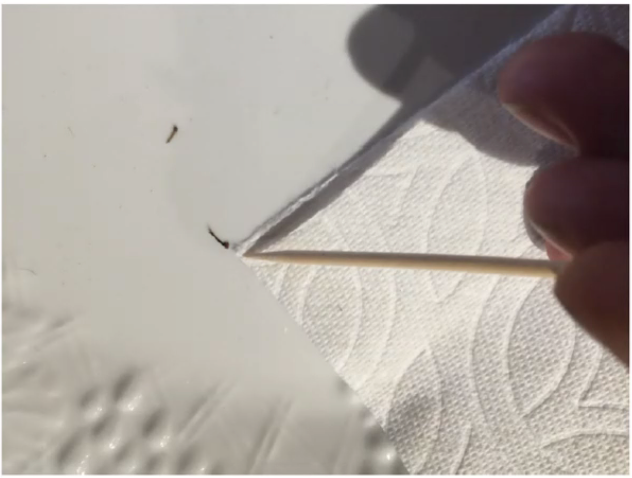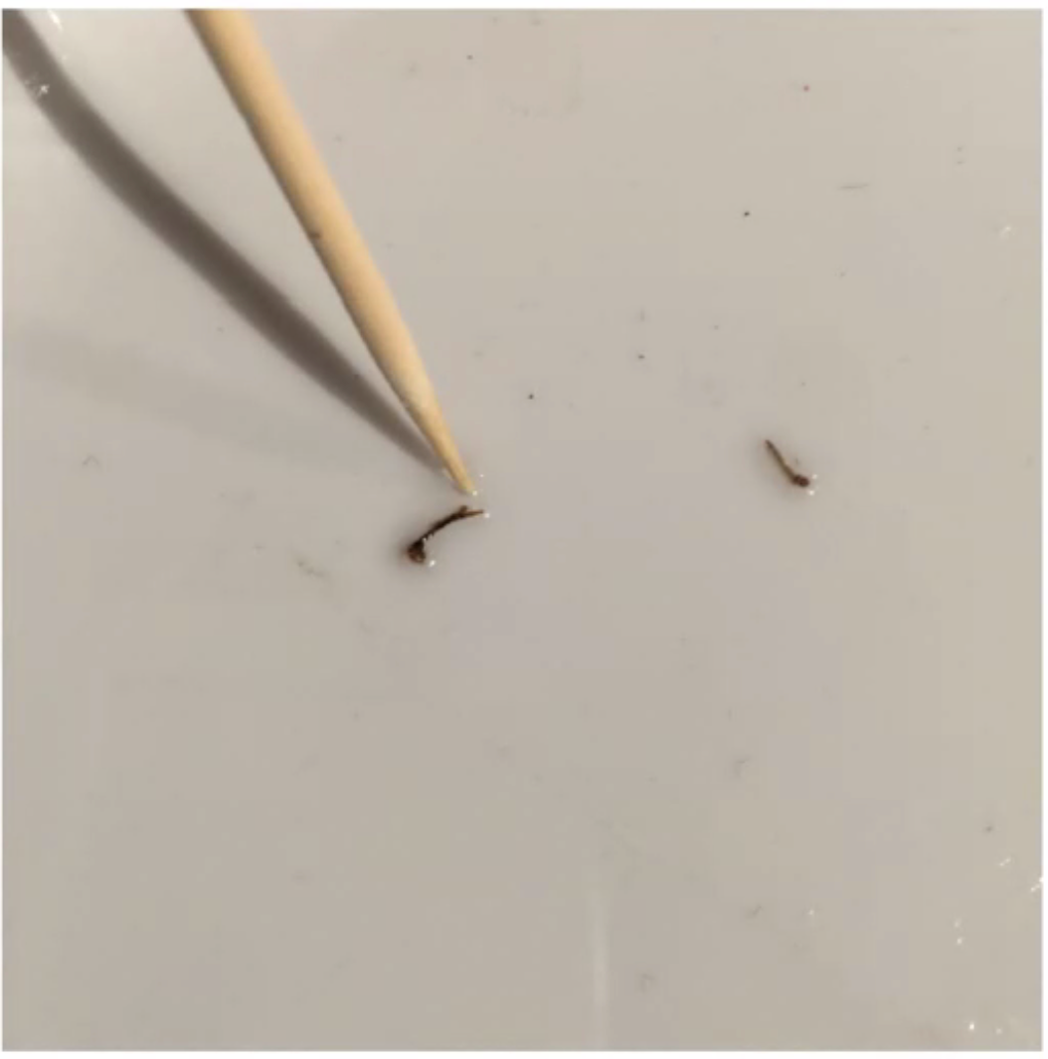

5. **Verify that the larva is a 3rd or 4th instar**

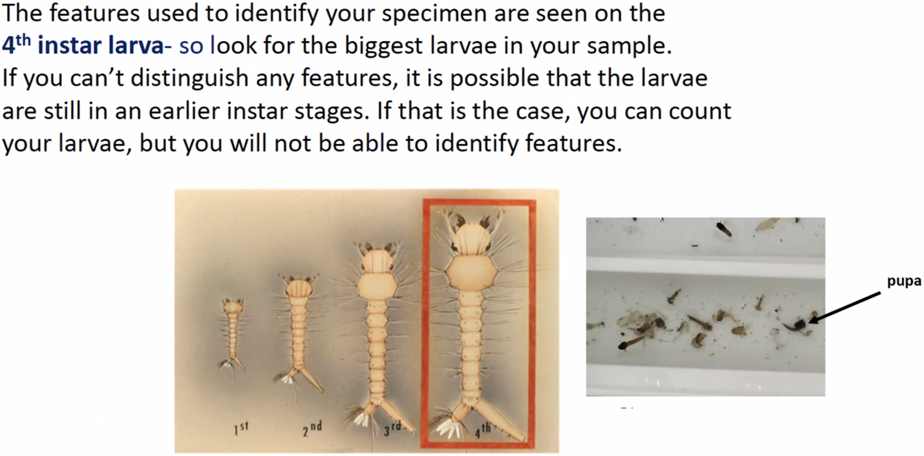

6. Wipe off any smudges on your phone’s camera lens. **Attach the 60X clip-on lens**. Depending on your phone/case, you may need to **remove your case** to properly attach and/or focus the lens. Turn on the **white light** (not UV).

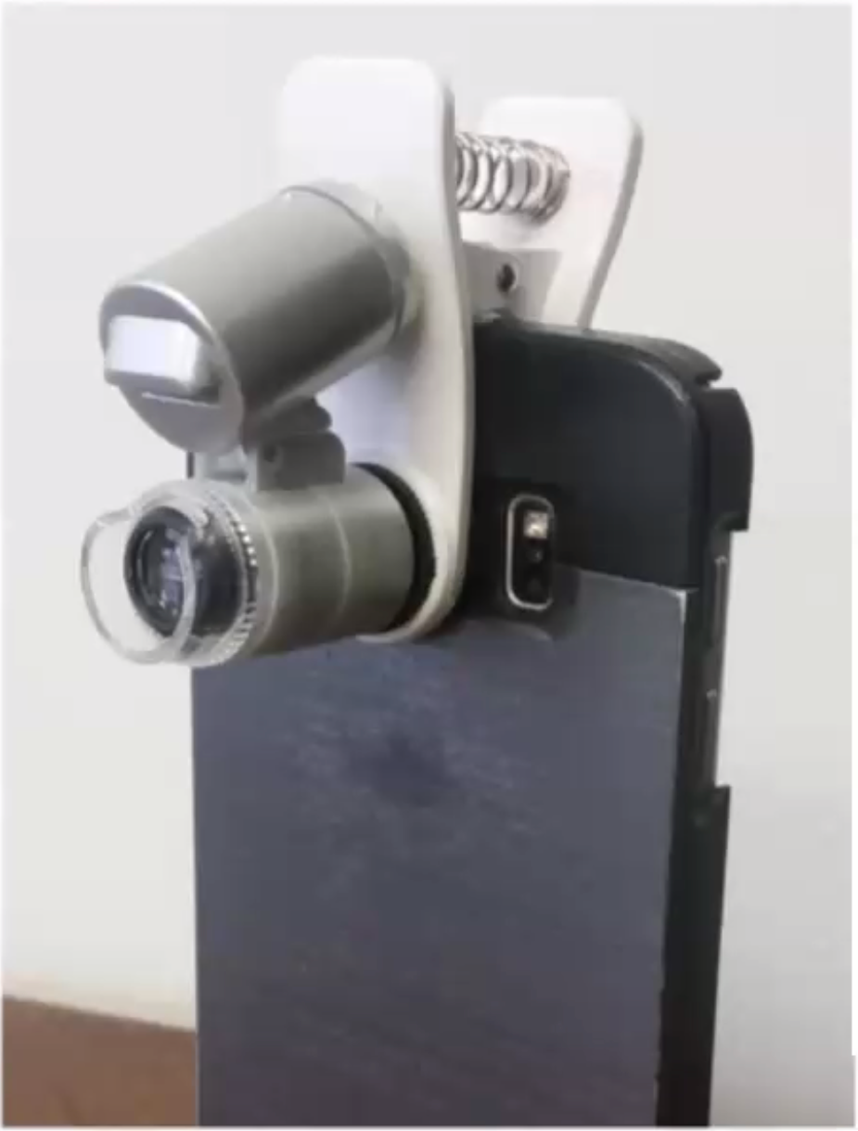 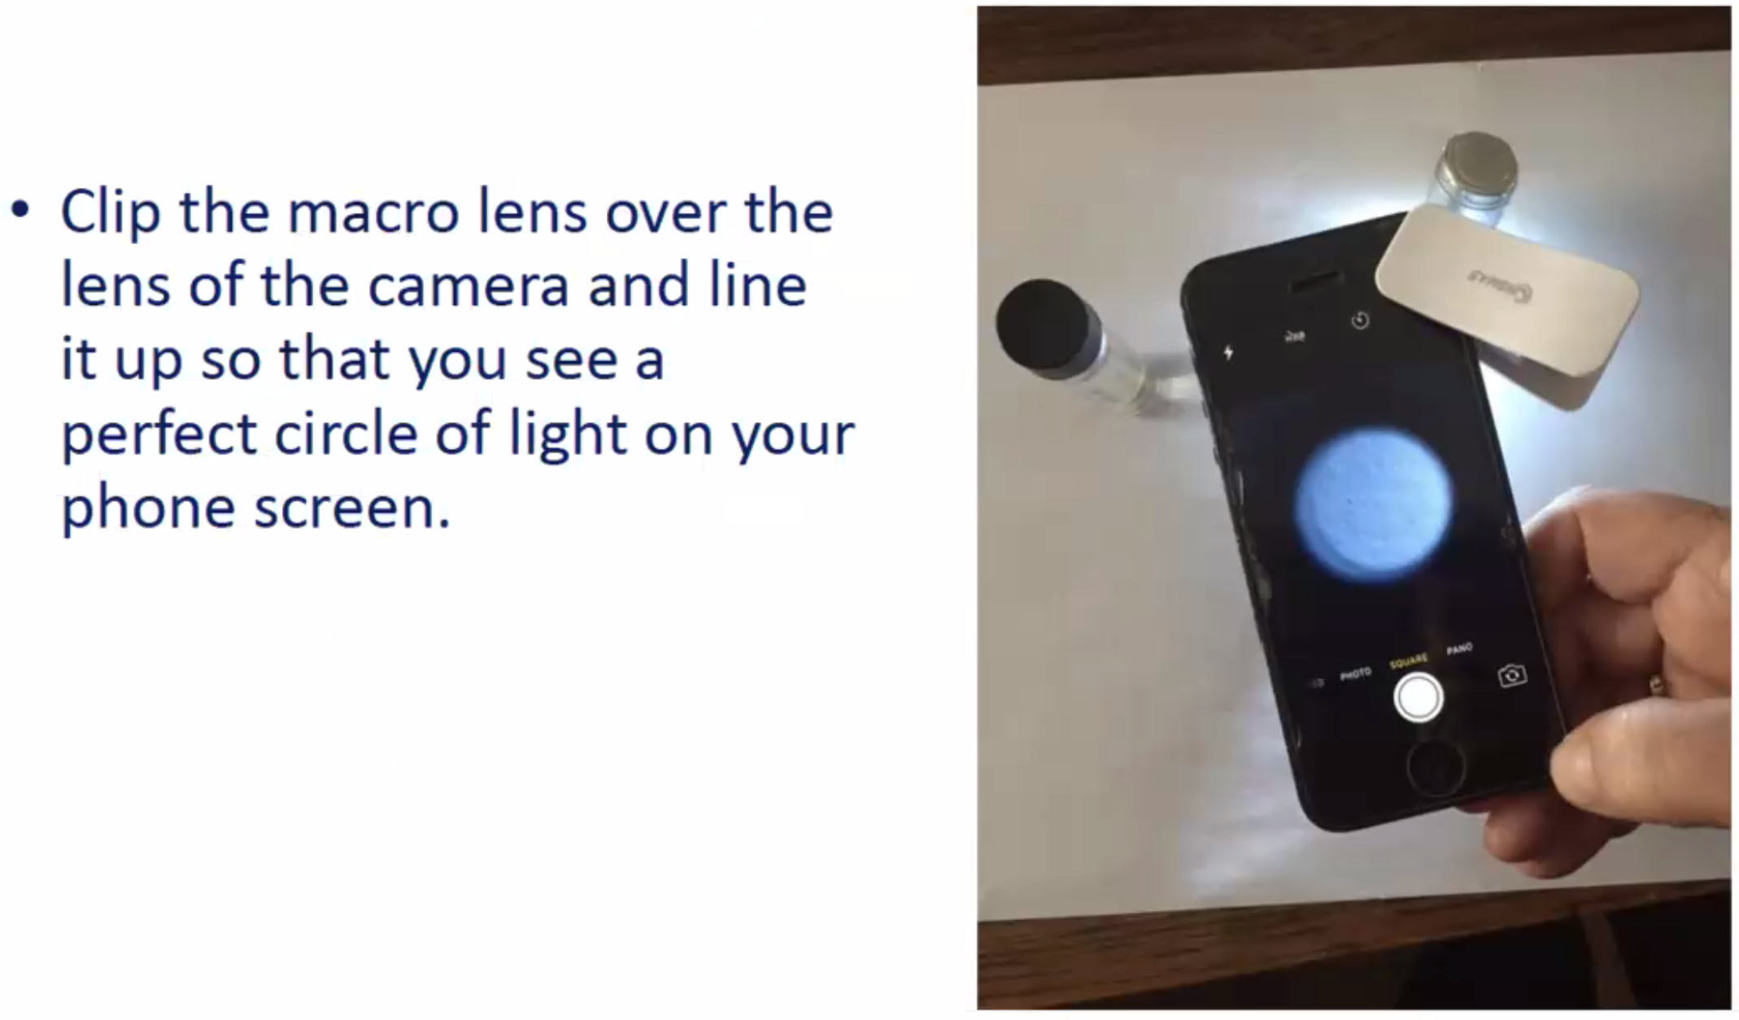

7. Get very close, so that the clear plastic collar is resting on the surface. Don’t pull out and expand the lens.

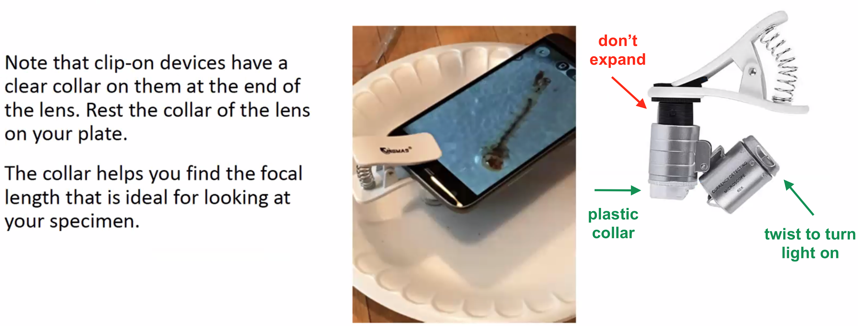

8. Line up the lens to the specimen. Make sure the orientation of the light doesn’t cast shadows that obscures the anatomy. **Tap the phone screen to focus** on the mosquito.

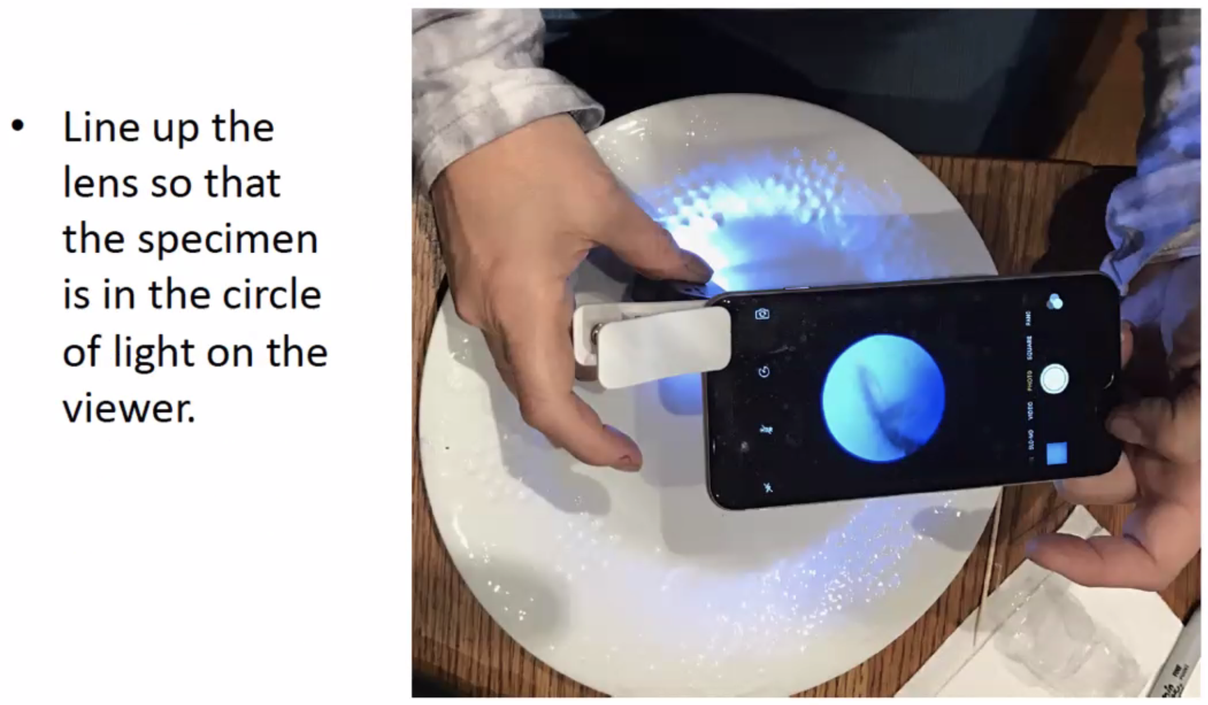

9. Take **TWO PHOTOS** of specimen's **FULL BODY**, including all the **HAIRS** ("setae") (below, #1). View photo and verify that 1). all the hairs are included (green box), and 2). that photo is in focus. Otherwise delete and retake.

10. Digitally zoom using the phone (e.g., pinch-drag). Tap the screen again to refocus, then take **TWO PHOTOS** of the **TAIL+HAIRS** (below, #2). View photo and verify that 1). all the hairs are included (green box), and 2). that photo is in focus. Otherwise delete and retake.

11. Move lens to the head, tap screen to refocus, and take **TWO PHOTOS** of the **HEAD+HAIRS** (below, #2-3). View photo and verify that 1). all the hairs are included (red/orange boxes), and 2). that photo is in focus. Otherwise delete and retake.

* Again, make sure to maintain this order of photos: full body, tail, head

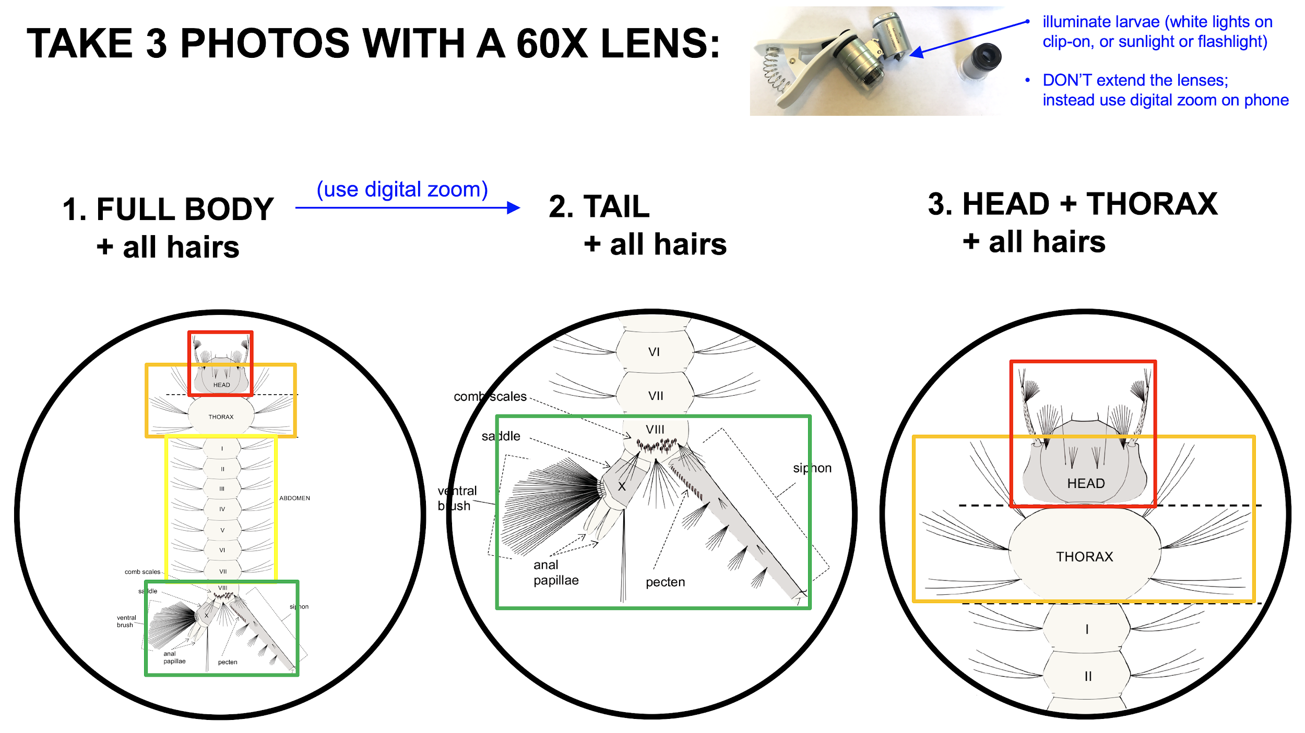

12. **Double check** that the three photos are in focus and contain all relevant hairs (otherwise delete and retake).

13. **Gently flip the larva over** with one or two toothpicks, and take the same **SIX PHOTOS** but of the **VENTRAL side**.

14. Time-permitting: take the same 3 photos of the dorsal side, with larva on the square **scaling grid**: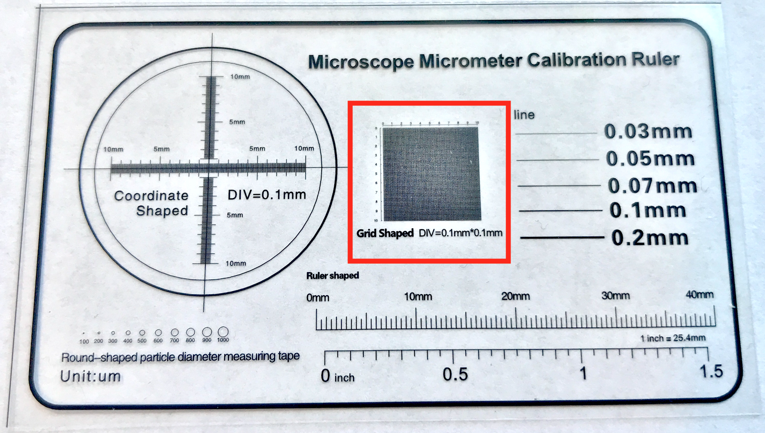

15. Transfer larva to the “used” container, then repeat steps for the next larval specimen.

16. At the end of the session, take another **photo of p.2** with any new notes

17. Leave containers in the room. After you leave the insectary room, store the plate etc. on the shelf.

18. **Inspection**. Make sure that there are no adult mosquitoes on your clothing, or flying around, before proceeding through the next door.

19. Write your name on the disposable lab coat, or dispose of it if not returning that week.

20. After the session, **immediately upload** photos per Step III, below.

#### 

#### B. Adults:

1. Under the session notes (p.1), write down the **location** (Adams lab, CDC) + **genus and species** (and CDC lineage info, if applicable) and **take a picture of this before proceeding**. Repeat this step at the beginning for each new species/lineage, crossing off the previous row. For photographing the same species/lineage, just make sure to photograph in sets of 20 (unpinned specimens) or 10 (pinned specimens) per step 5.

2. If it is a museum specimen, take an initial photo ofthe **specimen number and/or vial.**

3. Verify that specimen is reasonably **intact** (ideally no broken wings or missing legs).

4. Put specimen on the **white paper** or other white background, and under **normal indoor lighting.**

5. **PHOTOS**. Wipe off any smudges on your phone’s camera lens. Take photos of the specimen in one or two sets of 10, depending on the preservation (below). Note that unpinned specimens are higher priority than pinned. We only need pinned after the unpinned specimens are exhausted, and if they'd be necessary to reach the **50-specimen per species minimum** needed for our AI training:

**i. For an unpinned specimen** (e.g., fresh, frozen/bulk identified): **take 10 photos from different perspectives of the phone\***,for each of **two different positions of the specimen** (20 total). In other words, take 10 photos, flip over once, then take another 10. (*Will be either dorsal/ventral or left/right depending on configuration of preserved legs and wing etc. We will use one set of 10 for training, one set of 10 for testing*)

**ii. For a pinned specimen** (e.g., museum voucher): **take 10 different perspectives of phone\***.Since specimen is fixed, treat it as having only oneposition (10 total). Note if there is any damage (e.g., dorsal thorax morphology) or any obstruction from the pin/staging that may confuse the algorithm. This can be written in the session notes (p.1) in the subsequent line.

**\* For each set of 10:**

* phone should be **~4-6 inches** from specimen for each picture
* make sure to **tap the screen to focus** for each photo
* only use digital zoom, if need be (not an attachable macro lens)

a). Take **2** photos from directly above the specimen, from slightly different angles. Make sure that at least one captures the scutum (thorax) well.

b). Take **4** photos, one from each cardinal direction**, at **~60°** from the table

c). Take **4** photos, one from each cardinal direction**, at **~30°** from the table

** = 12, 3, 6, 9-o'clock

d). Verify that all 10 photos are in focus. Otherwise delete and retake the blurry photo(s)

e). If it’s an unpinned specimen, flip over and repeat steps a-d

6. Repeat steps 2-5 for the next adult specimen, until a total of 50 specimens are photographed for that species.

7. At the end of the session, take another **photo of p.2** with any new notes. **Immediately upload** all photos per Step III, below.

### III. Upload

1. Using the **Drive app**, immediately upload all photos -- **including photos of the session notes** (and museum specimen number and/or vial, if applicable) -- at the end of each session/day, to this Drive folder:

<https://drive.google.com/drive/folders/18RP2u1SMpJXqJi1jrd4pLFR3gqHxofG9?usp=sharing> [contact [ryanmcarney@gmail.com](mailto:ryanmcarney@gmail.com) if you need access]

2. Make sure to create new subfolders for your photos, according to the notepad/info photos and this schema:

**Larvae** or **Adults**

[Organization]

[Genus species_lineage*_generation#*_instar_stage or #days_sex]

[Location/lab*_your name_phone model]

[YYYY-MM-DD]_[#photos]_n=[#specimens]

*\*if applicable/available*

(blue text is for larvae only)

*for example*: Larvae

USF

**Anopheles stephensi_Nijmegen_388_4th_late_female**

**Adams_Lara Ve_iPhone 8**

**2021-04-01_122_n=10**

Adults

CDC

**Anopheles stephensi_STE2_11_male**

**Atlanta_Addy Ults_Samsung Galaxy S8**

**2021-04-01_201_n=10**

3. Retain and file the p.2 notes as a hard copy backup of the session notes